Jānis Zelmenis  Attorney at Law  Member of Latvian Bar Association, licensed attorney at law  BDO Law Founder and Managing Partner  Lecturer of EU law at Riga Stradina University for courses  EU Internal Market and EU Company Law | 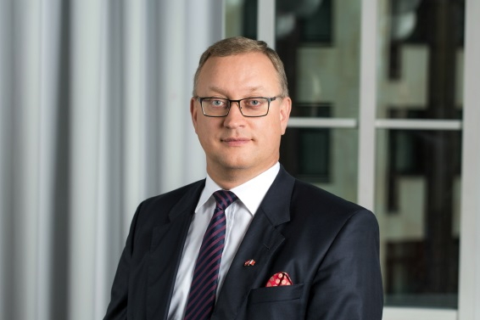

Education:
- Central European University, Master of Laws,
International Business Law (1995)
- Moscow State Institute of International Relations,
Master of Laws (LL.M.) (1993)

Expertise:

Jānis Zelmenis has over 20 years of experience in leading and providing professional services to a diverse range of clients, operating in different business sectors within the EU, Baltic and CIS states. Jānis Zelmenis is a tax and legal consultant with focus on acquisitions and company law being one of the most frequently quoted experts on tax issues, company mergers and acquisitions and restructuring deals, with a perfect knowledge of both local and international legislation.
General practicing areas are Commercial & Corporate Law, Tax Law, mergers and acquisitions, real estate, litigation and arbitration. Jānis Zelmenis expertise also includes many years of co-operation with commercial banks in Latvia, which he has consulted on tax issues and complicated purchase and acquisition deals and the necessary structuring, as well as advising on corporate governance issues Fortune 500 clients. As a tax expert, he has participated in drafting anti-money laundering laws.
Apart from his qualifications as a lawyer, Jānis also has experience in foreign affairs, he is founder and member of management board of Association of Consular Corps in Latvia. He has been Honorary Consul for the Republic of Malta in Latvia since 2006, and also worked in Latvia’s Embassy in Moscow, Russia. He has contributed to a variety of business publications. He is an author of a book Pendulum of Wealth published in Latvian and Russian languages in December 2015 that is devoted to international tax planning and privatization of Ventspils Nafta in Latvia.

He is also actively publishing articles in legal or commercial newspapers on current legislation, business and tax problems, organizing seminars and trainings for business owners and lawyers and participating in business and legal conferences worldwide.

