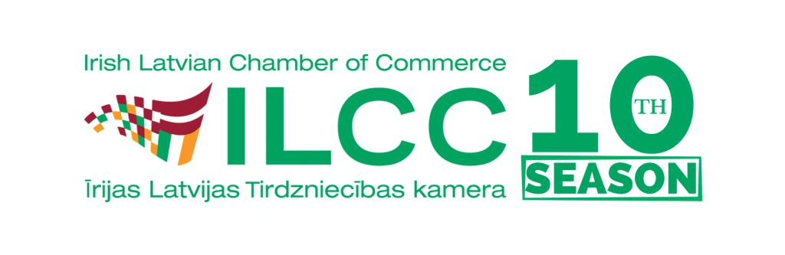
ILCC Board Candidate 2022
Full name of a Candidate
Brief CV
What experience you can share with ILCC
What input you could give to ILCC Board
Who would be your dream guest speaker at our event?
Please be realistic

Please submit the completed form to ILCC on or before 17.00 10th March, 2022.

